Streamlining Ticket Assignment for Efficient Support Operations
Project Documentation format
1. Introduction
Project Title: Optimizing User, Group, and Role Management with Access Control and Workflows
Team Members:
Team ID: LTVIP2026TMIDS71782
Team Size: 4
Team Leader: Ujjwala Priyadarshini Manda– Project Coordination, Application access, access control list, Flow
Configuration
Team Member: Rupa Sri Yelisetti–Users & Groups
Team Member: Ramakrishna Vinayak Arigela– Roles & Table Creation
Team Member: Samudrala S S N V Ranga Durga Mahathi– Assign users to group & Assign roles to user
2.Project Overview
Purpose
The purpose of this project is to implement a structured User, Group, and Role Management system integrated with Role-Based Access Control (RBAC) and automated workflow approvals using ServiceNow.
This system:
  - Reduces manual role assignment errors
  - Improves security through ACL enforcement
  - Automates approval workflows
  - Ensures proper access based on user roles
  - Enhances accountability and visibility

Features
• User creation and role assignment
• Group-based user management
• Role-Based Access Control (ACL configuration)
• Automated approval workflow (Flow Designer)
• Role-based data visibility
• Access request tracking and status updates
• Dashboard and reporting

Architecture
Frontend
• ServiceNow Service Portal
• Provides UI for users to request access and track approval status
• Dashboard view based on user role

Backend
• ServiceNow platform logic
• Business Rules
• Flow Designer (Approval Workflow)
• Access Control Lists (ACL)
• Handles role assignment and approval automation

Database
• ServiceNow internal database
• Stores users, roles, groups, approval records, and workflow logs

Setup Instructions
  - Prerequisites
• ServiceNow instance
• Web browser
• Internet connection
  - Installation
  - Login to ServiceNow instance
  - Create users (Alice – Project Manager, Bob – Team Member)
  - Create groups (Managers, Developers)
  - Create roles (Project_Manager_role, Team_Member_role)
  - Create custom table (User Access Management Table)
  - Configure fields (Status, Requested Role, Assigned Group, Approval State)
  - Setup ACLs for security (Create, Read, Write, Delete restrictions)
  - Create approval flow using Flow Designer
  - Activate workflow

Folder Structure
Optimizing_User_Group_and_Role_Management
│
├── 1. Table
│ └── project table (u_user_access_mgmt)
│ ├── task ID (String)
│ ├── task name
│ ├── due date
│ ├── assigned to
│ ├── Status (Choice: Pending/Approved/Rejected)
│ ├── Approval Date (Date/Time)
│ └── Comments (String)
│
├── 2. Roles
│ ├── Project_Manager_role
│ └── Team_Member_role
│
├── 3. Groups
│ ├── project team│
│
├── 4. Users
│ ├── Alice → Managers group
│ └── Bob → Developers group
│
├── 5. Access Controls (ACL)
│ └── User Access Management Table
│ ├── Create
│ ├── Read
│ ├── Write
│ └── Delete
│
├── 6. Flow Designer
│ └── Role Approval Flow
│ ├── Trigger: Access Request Created
│ ├── Action: Send Approval to Project Manager
│ └── Update Status
│
└── 7. Update Set
└── Optimizing_User_Group_and_Role_Management

Running the Application
• Open ServiceNow instance
• Login with credentials
• Navigate to User Access Management module
• Create access request
• System automatically triggers approval workflow
• Manager approves/rejects
• Status updates automatically

7. Authentication
• Role-Based Access Control (RBAC)
• Access Control Lists (ACL)
• Roles: Project Manager, Team Member, Administrator
• Secure login via ServiceNow authentication

8. User Interface
• Access request form
• Approval dashboard
• Role-based visibility
• Group-based access display
• Status tracking panel

9. Testing
• Functional Testing (Access request creation, approval flow)
• Security Testing (ACL enforcement)
• Performance Testing (Workflow execution time)
• Load Testing (Multiple access requests)
10. Screenshots / Demo
Demo link:

https://drive.google.com/file/d/1G-_s0lBLQGQlJEoASRaAHqR4PB3nuzIk/view?usp=sharing
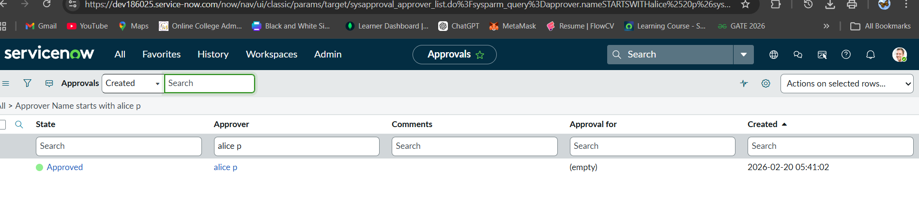

11.Known Issues
The approval workflow supports only a single-level approval (Project Manager only).
• The system is currently designed for a small team structure (Alice and Bob).
• Role configuration must be manually updated when adding new users.
• The approval logic is limited to record creation events only.
• Reporting and analytics dashboards are not implemented in this version.
• Access Control Lists (ACLs) must be manually modified for additional roles.
• The system does not currently support multi-stage or conditional approvals.
- Future Enhancements
• Implementation of multi-level approval workflows (e.g., Manager → Director → Admin).
• Automatic role assignment when new users are created.
• Dynamic approval routing based on task type or project category.
• Dashboard integration for real-time task and approval tracking.
• Email notifications for approval requests and status updates.
• SLA (Service Level Agreement) tracking for task completion deadlines.
• AI-based task categorization and smart routing.
• Workload-based task assignment to balance team responsibilities.
• Integration with external systems for project reporting and analytics.

